Year 9 Higher booklet
Week beginning May 4th 2020

Student’s name.............................................................................

Teacher:..........................................................................................

Key skills starter:
Q1)  -423 + 511  = 88 | Q7)  -29.4 + – 13.9  = -43.3
Q2)  479.5 $÷$ -7  = -68.5 | Q8)  16.7 x 14.6 =  = 243.82
Q3) In a normal deck of cards what is the probability of picking a picture card from the deck? Put your answer in its simplest form.  = 12/52 = 3/13 | Q9)  What is the term to term rule of this sequence?  19, 11, 3, -5 ….  -8n + 27
Q4)  What is 7/12 as a percentage?  = 58.3… % | Q10)  What is the Lowest Common Multiple of 16 and 18?  = 144
Q5)  What is the Highest Common Factor of 124 and 252?  = 4 | Q11)  Factorise…  36a$b^{4}c^{5}$ – 24$a^{2}b^{2}c$  12a$b^{2}c ( 3b^{2}c^{4} - 2a )$
Q6)  $5\frac{2}{5}- 3\frac{6}{7}=$ $\frac{54}{35}=1\frac{29}{35}$ | Q12) Order the following from smallest to largest  0.37, 1/3, 0.39%, 0.401, $\frac{9}{20}$  0.39%, 1/3, 0.37, 0.401, 9/20

Solving equations:
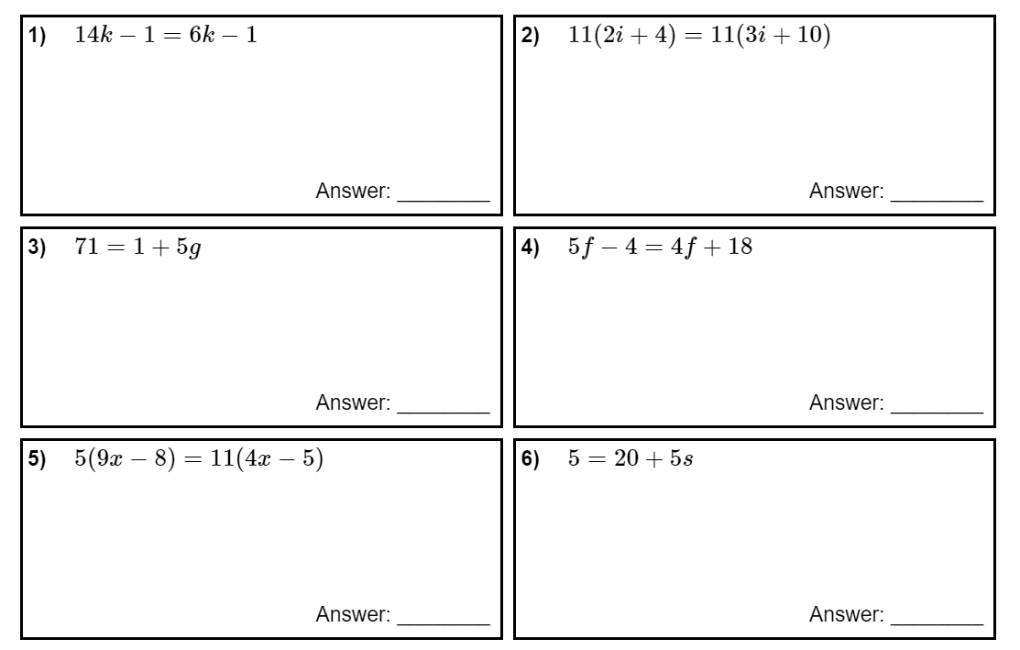
s = -3
x = -15
f = 22
g = 14
I = -6
k = 0

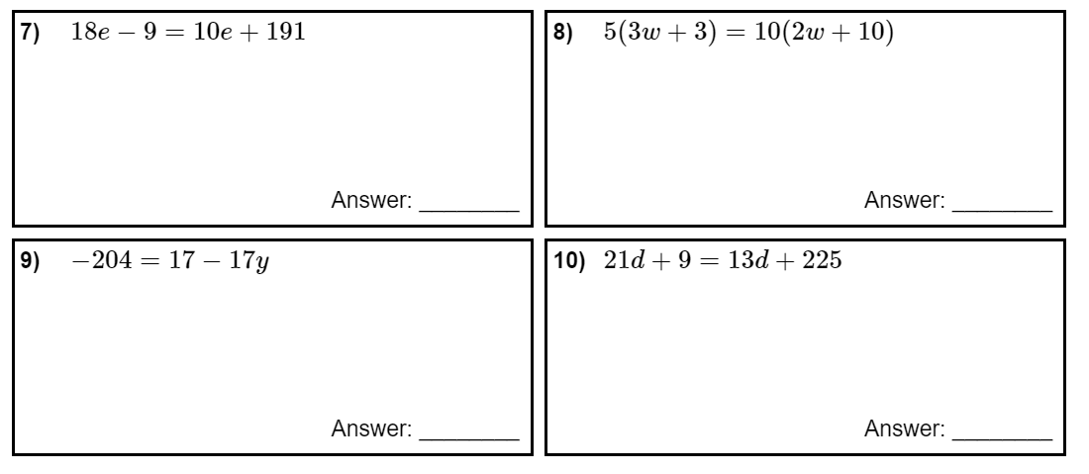
d = 27
y = 13
w = -17
x = 25

Ratio and proportion:
1. Simplify 49 : 63 7 : 9
2. A football team played 22 games and won 10. What is the ratio of the number of wins to the number of games played in its simplest form? 10 : 22 5 : 11

3. A yoga class has 18 girls and 12 boys.
a) What is the ratio of girls to boys in its simplest form? 18 : 12 3 : 2
b) What is the ratio of girls to the class total in its simplest form? 18 : 30 3 : 5

4. Lauren shares money between herself, Millie and Sana in the ratio of 3:4:5. Millie gets £32. How much money should Lauren and Sana have? Lauren = £24, Sana = £40

5. When 2: 𝑥 = 3: 6, find the value of 𝑥. x = 4

6. 180 people go bowling, the ratio of adults to children is 5 : 4. How many more adults go?
100:80 20 more adults
7. Simplify these ratios (be careful of the units)
a) 1 hour : 20 mins = 60 : 20 = 3 : 1
b) 2 hours : 30 mins = 120 : 30 = 4 : 1
c) 50p : £2.50 = 1 : 5
d) 20cm : 15cm = 4 : 3

8. Simplify these ratios
- 16 : 8 : 12 = 4 : 2 : 3
- 24 : 68 :96 = 12 : 34 : 48 = 6 : 17 : 24
- 9 : 108 : 45 = 1 : 12 : 5

10. An ice company charged £3.40 for 4 bags of ice. If a convenience store bought 6 bags of ice, how much would it have cost them? £5.10

11. Haley spent 35 mins playing on her phone. That used up 1 ⁄9 of her battery. How long would she have to play on her phone to use the entire battery? 315 mins = 5 hours 15 mins

- In a class 18 students support Liverpool, 9 support Chelsea and 6 support Arsenal.
- What proportion of the students support Liverpool? 18/33 = 6/11
- What proportion of the students support Arsenal? 6/33 = 2/11
- What is the ratio of Liverpool : Chelsea : Arsenal fans in the class in its simplest form? 18 : 9 : 6
6 : 3 : 2
- Below are the ages of 20 students in a group.
14 | 9 | 8 | 12 | 11 | 14 | 9 | 10 | 12 | 13
8 | 7 | 12 | 11 | 10 | 10 | 8 | 15 | 9 | 14

- What proportion are over the age of 9? 13/20
- What proportion are 12 years old or over? 8/20 = 2/5

- Here are the ingredients for a cake for 8 people.
- 150g butter or margarine, softened
- 120g caster sugar
- 2 medium eggs
- 140g self-raising flour
- If you wanted enough cake for 24 people how many eggs would you need? 6 eggs

- If you wanted enough cake only for 6 people, how much caster sugar and butter would you need? Caster sugar = 90g, butter = 112.5g

- How much self-raising flour would you need for 12 people? 210g

- The ratio of brown eyes to blue eyes to green eyes in a class was 5 : 3 : 2.
- What proportion of the class have blue eyes? 3/10
- What proportion of the class have brown eyes? 5/10 = 1/2

$17) \frac{4}{7}$ of a class are wearing the school jumper. The rest are not.
Write the ratio of those wearing the jumper to those not. 4 : 3

- Below is a list of the favourite colours of a group in a class
Red blue blue green purple red orange red green pink red yellow
- What proportion of students chose red? 4/12 = 1/4

- What proportion chose blue? 2/12 = 1/6

- In a class $\frac{1}{7}$ get a bus to school, $\frac{4}{7}$ walk to school and the rest get driven in a car.
Write a ratio of those that bus : walk : car to school. 1 : 4 : 2

- Here is a recipe for brownies that serve 6 people.
- 150g butter
- 160g milk chocolate
- 80g plain flour
- 40g cocoa
- 50g white chocolate
- 3 large eggs
- 250g golden syrup

- How many eggs would I need to serve a party of 84 people? 42 eggs

- How much butter would I need to serve a party of 21 people. 525g

- List the amount of each I would need to just serve 8 people (to 1dp).
200g butter
213.3g Milk chocolate
106.7g flour
53.3g cocoa
66.7g white chocolate
4 large eggs
333.3g golden syrup

Percentage Overview
Non Calculator
1. Find 18% of £70 £12.60
2. Find 1.3% of 60 0.78
3. Increase £28.00 by 115% £60.20
4. Decrease £90 by 19% £72.90

Calculator allowed now
5. Kevin scores 49 out of 58 in an exam. What percentage did she get (to 2dp)?
49/58 =84.5%
6. Luke buys a painting for £1120 and sells it for £1432. What was the percentage increase in its value? (2 d.p) 312/1120 = 0.2786 x 100 = 27.86%
7. Jake buys a motorbike for £3900 and sells it for £2750.
(a) By how much has its value decreased as a percentage? 1150/3900
29.49%
(b) What % of its original value is it now worth? 70.51%

8. Lorna buys a T shirt in the sale. The price of the T shirt after a 22% discount is £29.50. What was the original price of the T shirt? 29.5 $÷$ 0.78 = £37.82

9. Jane bought a house for £185,000. He did some work on the house which raised its value by 8%. What is the house now worth? £199, 800
10. James has a wage rise. After a 22% increase in her weekly salary she now earns £538.20 a week. How much did James earn before the increase?
£441.15
11. Write down the multiplier used to increase a quantity by 9% = 1.09
12. Write down the multiplier used to increase a quantity by 121% = 2.21
13. Write down the multiplier used to decrease a quantity by 48% = 0.52
14. Write down the multiplier to decrease a quantity by 29.9% = 0.701

15. Bank A offers me 4.8% simple interest per year for 4 years on my £4200 investment. Bank B offers me 0.4% compound interest per month for 4 years.
Which Bank should I go with? You must show your working…
A = £201.60 per year x 4 = 806.40 £5006.40
B = 4200 x ${1.004}^{48}$ = £5087.07 Therefore Bank B better option

16. A rock decays at a rate of 3.2% per year. The initial mass of the rock is 62kg.
(a) What is the mass of the rock after 6 years? 62 x ${0.968}^{6}$ = 51kg
(b) How long will it take for the rock to have a mass of less than 8kg?
62 x ${0.968}^{62}$ = 8.25kg 62 x ${0.968}^{63}$ =7.99kg therefore 63 years
17. A car goes on sale for 19.5% less than original. It now costs £10,630. What did it cost before the sale? 10630 $÷$ 0.805= £13, 204.97

