Year 9 English Home Learning Work – Week 12
Romeo in Love – ‘Romeo & Juliet’
This week you are going to start to explore what our protagonist, Romeo, thinks and how he acts when he is in love. William Shakespeare’s play, Romeo & Juliet, is best known as the greatest love story ever told. However, according to William Makepeace Thackeray, the writer of the novel Vanity Fair, ‘Love makes fools of us all’.
You can decide whether you think Romeo makes a fool of himself or if he shows us the meaning of true love.

TASK 1: Read the extract below taken from the second half of act 1, scene 1 of Romeo & Juliet.
The fight between the Capulets and Montagues is over and the Prince has warned them what will happen if there is more fighting. Montague talks to Romeo’s friend Benvolio, telling him that he and Lady Montague are worried about Romeo, as he appears to be depressed. Benvolio says he will talk to Romeo and find out what is wrong with him. Romeo tells Benvolio he is in love with Rosaline, a woman he has never actually met!
Benvolio. Good-morrow, cousin.
Romeo. Is the day so young?
Benvolio. But new struck nine.
Romeo. Ay me! sad hours seem long.
Was that my father that went hence so fast?
Benvolio. It was. What sadness lengthens Romeo's hours?
Romeo. Not having that, which, having, makes them short.
Benvolio. In love?
Romeo. Out—
Benvolio. Of love?
Romeo. Out of her favour, where I am in love.
Benvolio. Alas, that love, so gentle in his view,
Should be so tyrannous and rough in proof!
Romeo. Alas, that love, whose view is muffled still,
Should, without eyes, see pathways to his will!
Where shall we dine? O me! What fray was here?
Yet tell me not, for I have heard it all.
Here's much to do with hate, but more with love.
Why, then, O brawling love! O loving hate!
O anything, of nothing first create!
O heavy lightness! serious vanity!
Mis-shapen chaos of well-seeming forms!
Feather of lead, bright smoke, cold fire,
sick health
Still-waking sleep, that is not what it is!
This love feel I, that feel no love in this.
Dost thou not laugh?
Benvolio. No, coz, I rather weep.

TASK 2: Fill in the table to explain the meaning of each of the quotes.

Quote | Meaning
tyrannous and rough in proof

whose view is muffled still

Here's much to do with hate, but more with love
O brawling love! O loving hate!
Mis-shapen chaos of well-seeming forms!
This love feel I, that feel no love in this

TASK 3: Answer the questions that follow in full sentences.
- Which of the following words best describes how Romeo is feeling? Explain your choice.

excited/optimistic/miserable/lonely

- Which language technique has Shakespeare used in the phrases ‘Feather of lead’ and ‘heavy lightness’ and what is he showing about the way Romeo is feeling by using this technique?

- What do you think real love is? Is Romeo’s love for Rosaline real love?

TASK 4: Read the following extract.

Later on, in scene 5 of act 1, Romeo and his friends have gatecrashed a ball held by the head of the rival family – Lord Capulet. It is at this ball that Romeo first sees Juliet. Before he approaches her, he describes her to the audience.
ROMEO
O, she doth teach the torches to burn bright!
It seems she hangs upon the cheek of night
Like a rich jewel in an Ethiop's ear;
Beauty too rich for use, for earth too dear!
So shows a snowy dove trooping with crows,
As yonder lady o'er her fellows shows.
The measure done, I'll watch her place of stand,
And, touching hers, make blessed my rude hand.
Did my heart love till now? forswear it, sight!
For I ne'er saw true beauty till this night.

TASK 5: Find quotations from the poem that fit with each of the following images.
IMAGE | QUOTE

TASK 6: Read the following extract.

Shortly after seeing Juliet, Romeo walks up to her and they speak their first words to each other. Neither of them know that they are from the rival families of Capulet and Montague.

ROMEO
What is a Sonnet?
- A type of poem that deals with themes of love and/or death

- It contains 14 lines

- The rhyme scheme is abab cdcd efef gg

- It’s written in iambic pentameter (10 syllables per line with 5 stresses – it sounds like a heartbeat)
If I profane with my unworthiest hand A
This holy shrine, the gentle fine is this: B
My lips, two blushing pilgrims, ready stand A
To smooth that rough touch with a tender kiss. B
JULIET
Good pilgrim, you do wrong your hand too much, C
Which mannerly devotion shows in this; D
For saints have hands that pilgrims' hands do touch, C
And palm to palm is holy palmers' kiss. D
ROMEO
Have not saints lips, and holy palmers too? E
JULIET
Ay, pilgrim, lips that they must use in prayer. ?
ROMEO
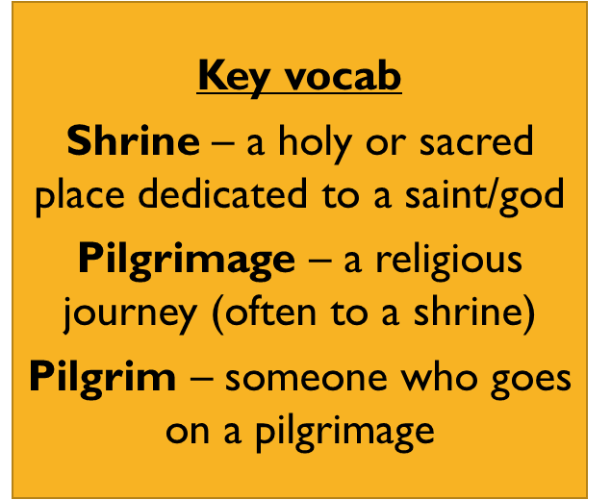
O, then, dear saint, let lips do what hands do; ?
They pray, grant thou, lest faith turn to despair. ?
JULIET
Saints do not move, though grant for prayers' sake. ?
ROMEO
Then move not, while my prayer's effect I take. ?

TASK 7: Complete the following tasks.
- Work out the rhyme scheme (pattern of rhyme) for the rest of the poem e.g. A, B etc.
- Read the information ‘What is a Sonnet’ above. List which of the elements of a Sonnet are used when Romeo & Juliet first meet.
- Identify three differences between how Romeo thinks and behaves when he is in love with Rosaline (act 1, scene 1) and how he thinks and behaves when meets Juliet (act 1, scene 5).

Challenge task: (optional)
Compare the way Shakespeare has used language and poetic techniques in all three of the extracts you have looked at today. Present your analysis in any form you choose.

